**Outputs for**

**Developing an E-commerce Website for Sporty Shoes**

**Flow chart:**

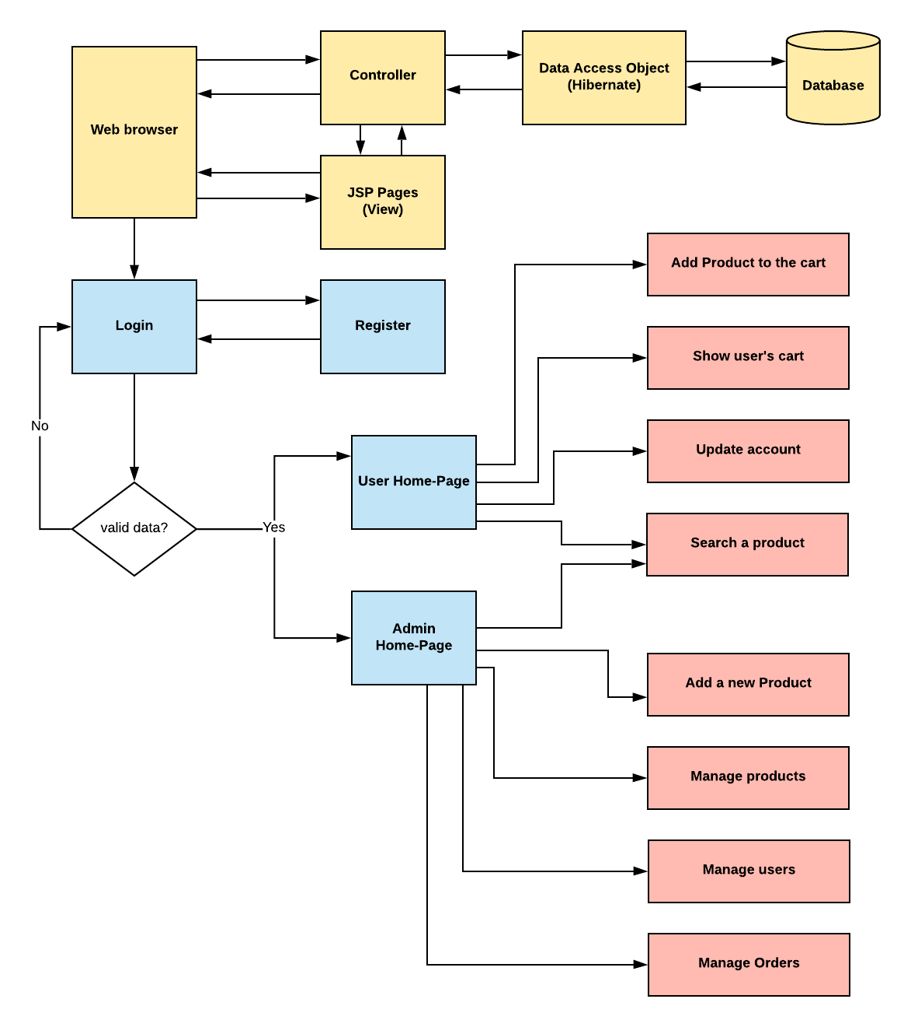

1. **Register page:**

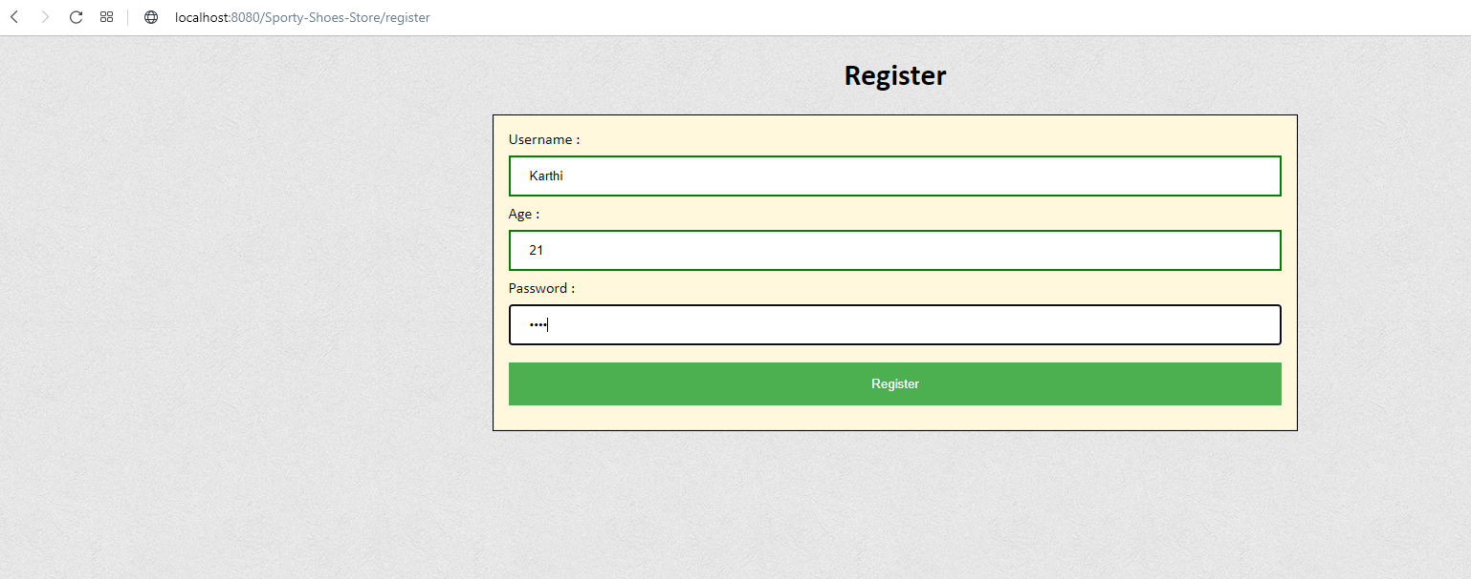

1. **Login page:**

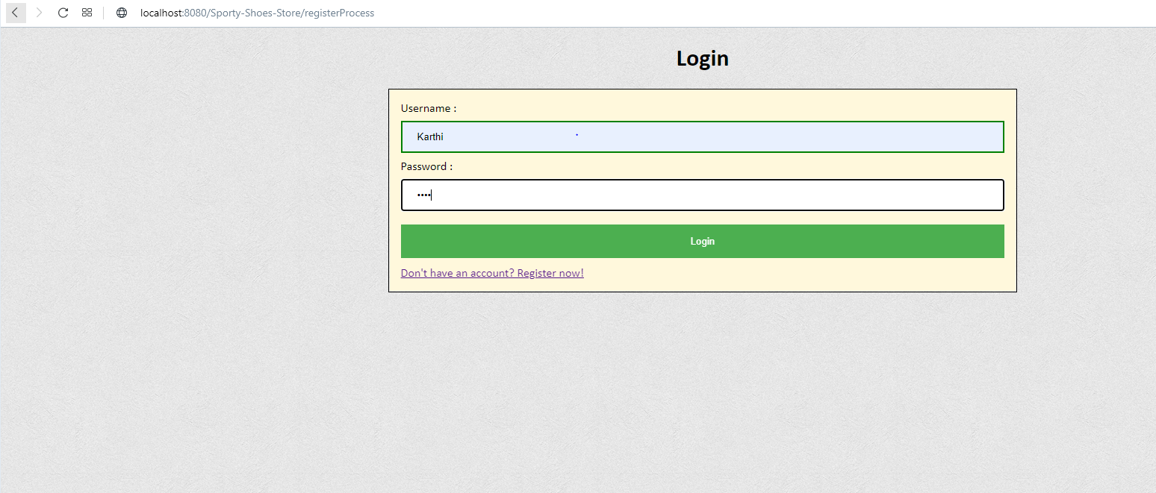

1. **Users home page:**

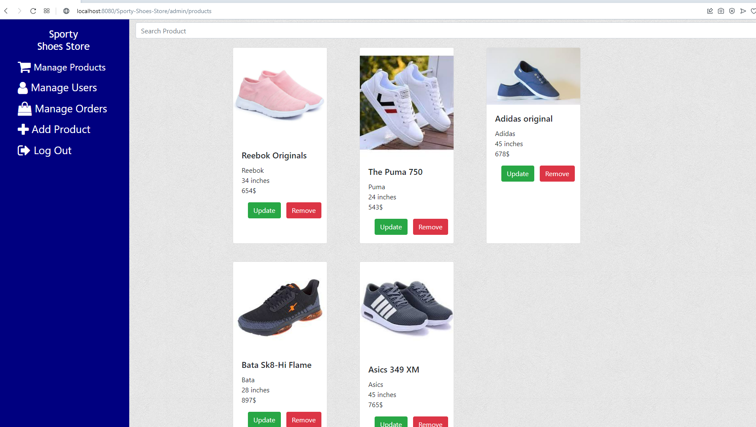

1. **Users cart page:**

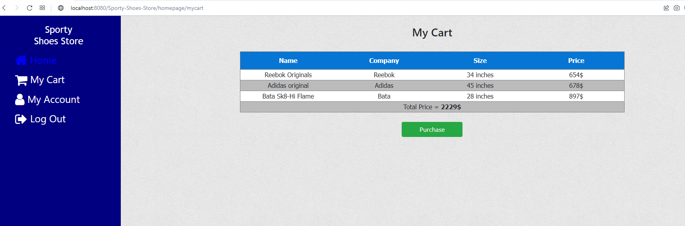

1. **Users update account page:**

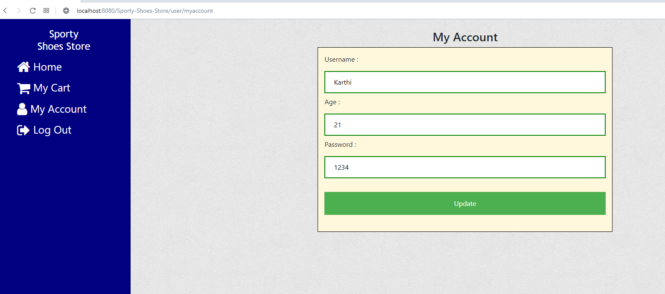

1. **Login as admin:**

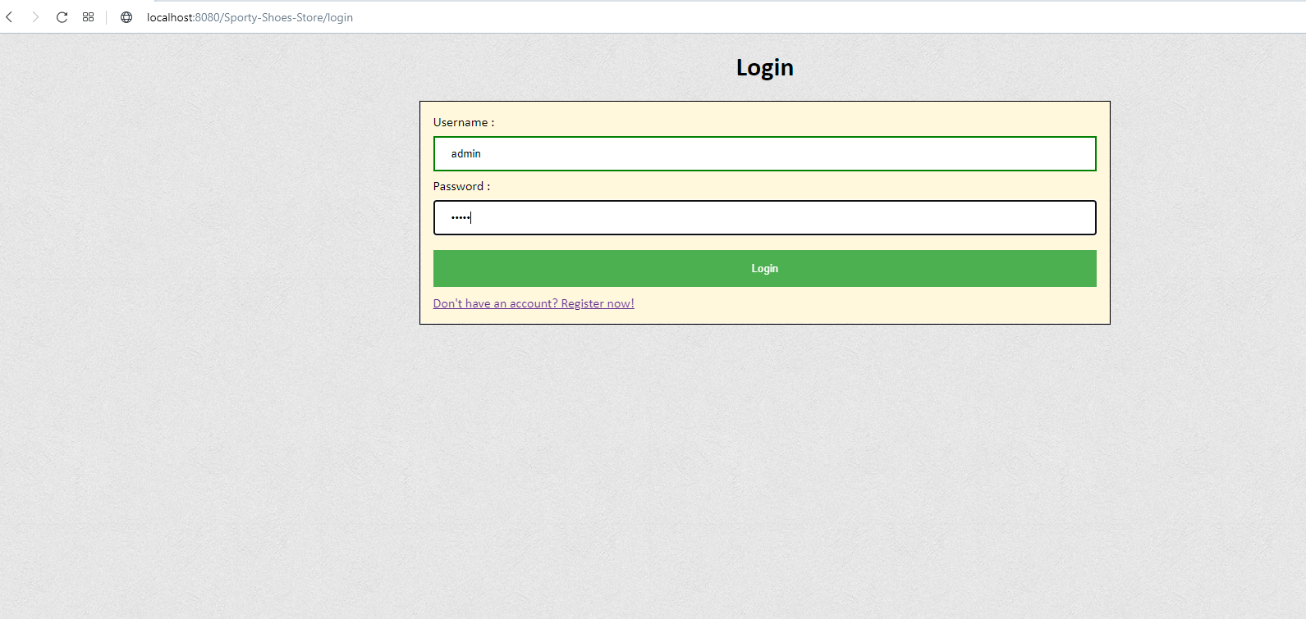

1. **Admins manage product page:**

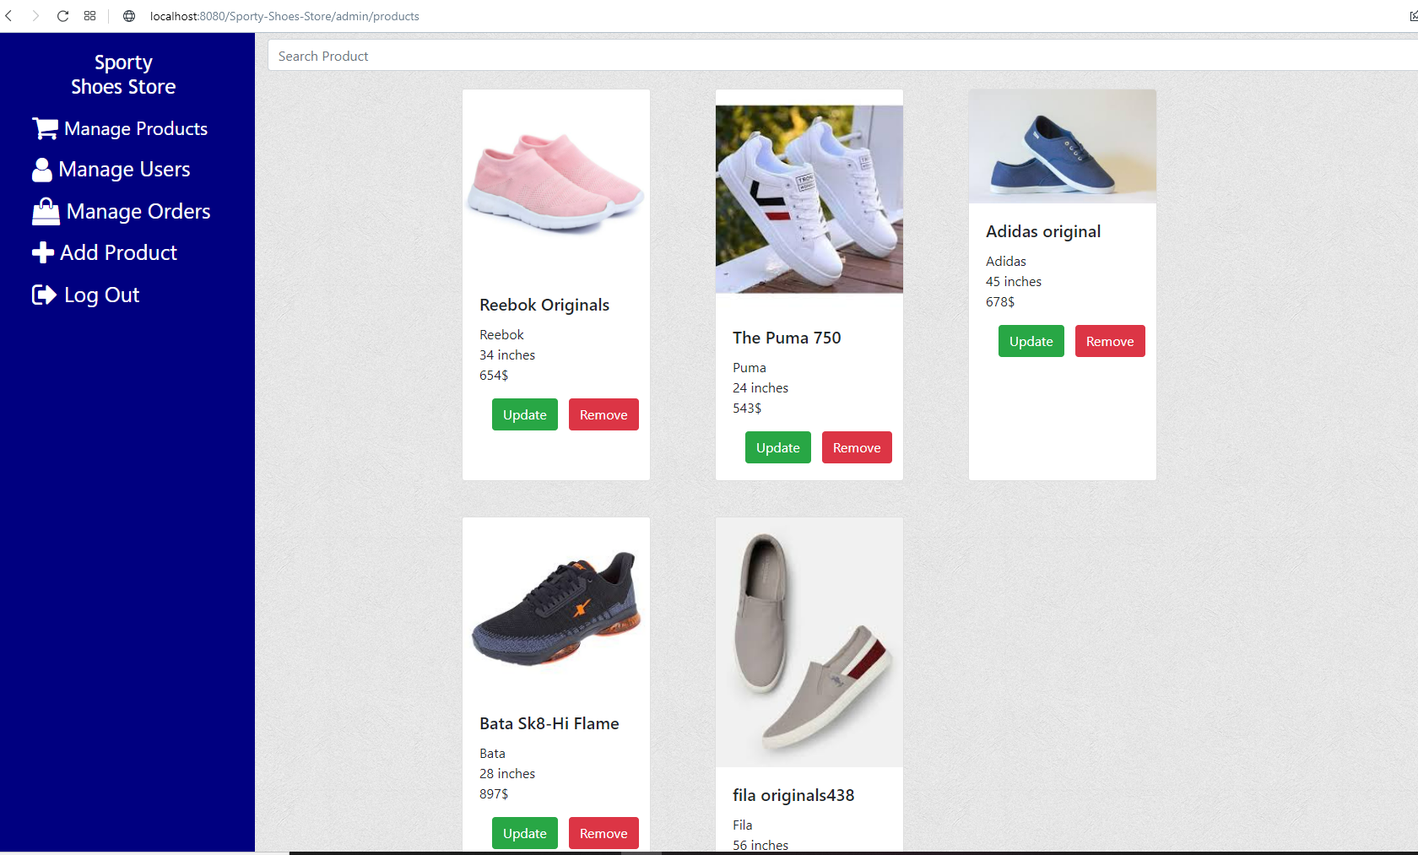

1. **Update products page:**

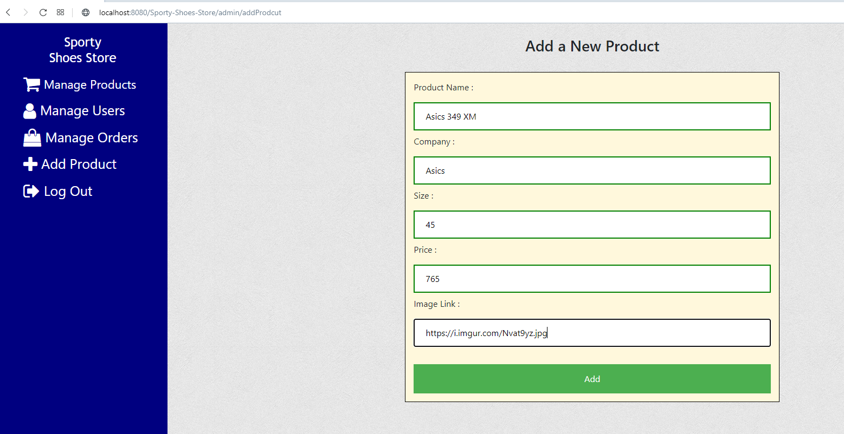

1. **Search a product by name:**

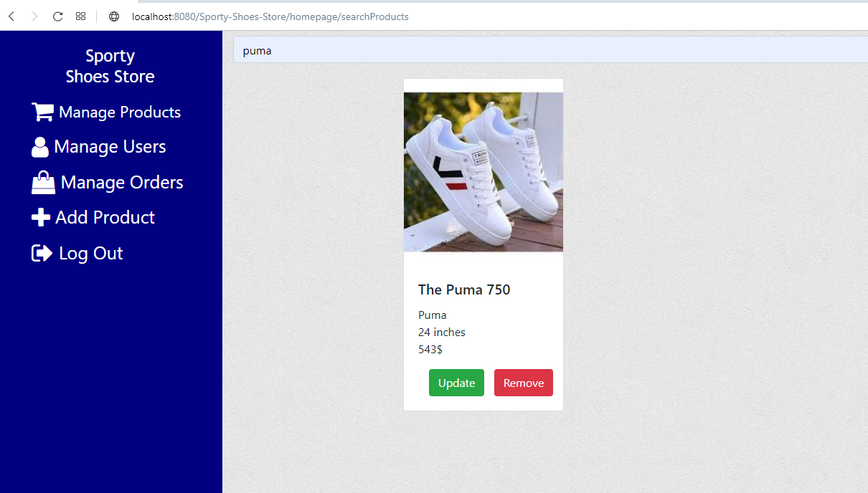

1. **Manage user’s page:**

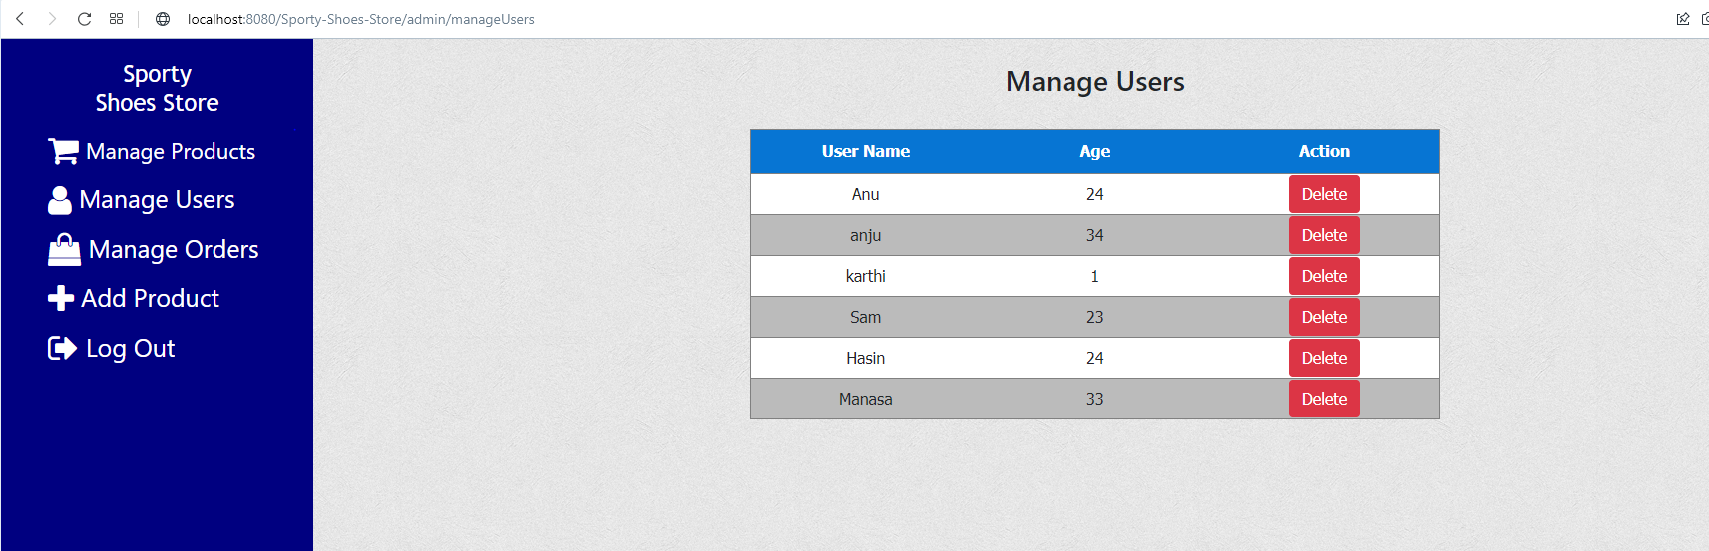

1. **Manage orders:**

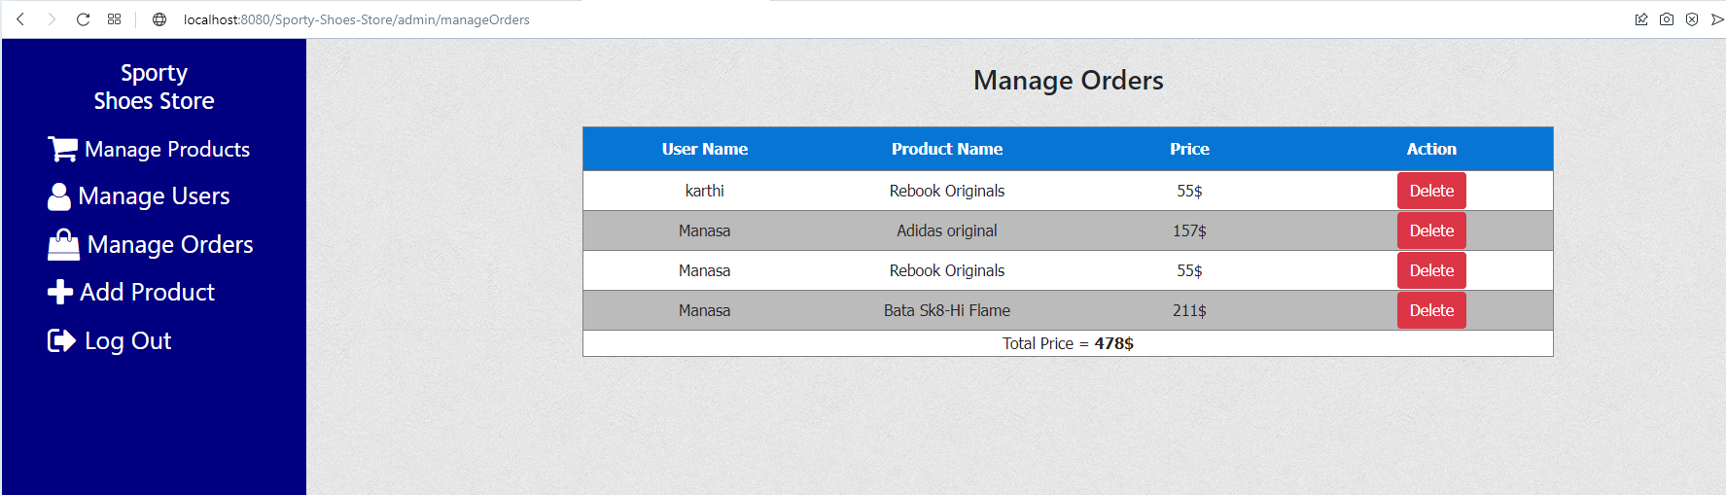

1. **Add a new product to the system.**

